_____________________________________________________________________________

FOR IMMEDIATE RELEASE
Contact: Meredith Michaels, Chief Development Officer
516.731.7880 ext. 232 ∙ mmichaels@bbbsli.org ∙ www.bbbsli.org

LIZ MEYERS, RICH GROSSI, MIKE QUATTRUCCI AND PRAVEEN ANUMOLU APPOINTED AS NEW SLATE
BIG BROTHERS BIG SISTERS OF LONG ISLAND BOARD OF DIRECTORS

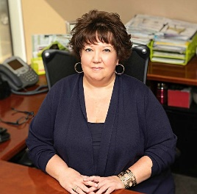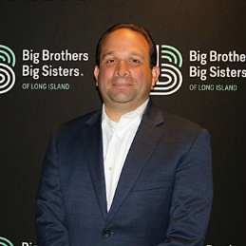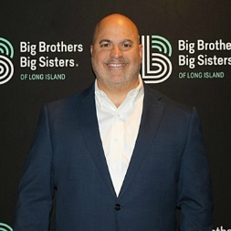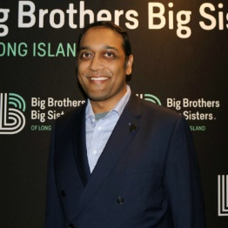
Liz Meyers Rich Grossi Mike Quattrucci Praveen Anumolu

Long Island, NY (June 2022) – Big Brothers Big Sisters of Long Island (BBBSLI) Board of Directors welcomes Liz Meyers, Board Chair, Rich Grossi, Vice Chair, Mike Quattrucci, Treasurer and Praveen Anumolu, Secretary.

Liz Meyers is the Executive Vice President of Purchasing and Global Sourcing for Darby Dental Supply, LLC. She is responsible for all aspects of domestic and international product sourcing and procurement, SKU optimization, inventory management, and maintaining vendor relations. Liz also spearheads Darby Gives Back-the philanthropic division of Darby Dental Supply. She has served on the BBBSLI Board since 2014 and has been an active member of the Catwalk for Kids Fashion Show as Co-Chair, the Holiday for Kids Sake Program and has been instrumental in securing funding for various projects, most recently the Big/Little Patio and the newly created Darby Dental Kids Closet. “I am both humbled and honored to accept the position of Board Chair for Big Brothers Big Sisters of Long Island. My goal for the next two years is to work with the Agency Leadership Team and the Board of Directors to promote program growth and sustainability by ensuring intentional board practice, careful stewardship, and overall organizational health, which will allow BBBSLI to achieve our mission of serving more children in our Long Island communities.”

Richard Grossi is the Chief Executive Officer at ION, the global leader in trading, treasury and risk management solutions for the energy, commodities, corporate and financial services industries serving over 2,300 clients with over 80,000 users worldwide. ION’s products manage $5 trillion dollars of cash balances and central bank reserves and operate at over 60% of the worlds global energy companies. As CEO of ION, Rich is responsible for leading day-to-day management and implementing and executing the company’s operational goals and long-term strategy. Mr. Grossi joined the BBBSLI Board of Directors in 2014 and has played an active role in its fundraising efforts, Holiday for Kids’ Sake Program and most recently, their newly created Rise Up Program.

Mike Quattrucci is Vice President of Sales at Red Hat, Inc., the world’s leading provider of enterprise open-source solutions, using a community-powered approach to deliver high-performing technologies. Mike became involved with BBBSLI in 2017 and served on the President’s Council prior to joining the Board. He holds BA and MBA degrees from Hofstra University and resides in Smithtown, NY with his wife and two children.
Praveen Anumolu is Director of Engineering Services for ASR International Corporation, a worldwide management and technical support services company. From 2004 through 2016, he previously served as a volunteer Big in the organization. Mr. Anumolu is a graduate of Cornell University with degrees in Geological Sciences and Electrical and Computer Engineering. He lives in Smithtown with his family and stays active in the local community. Praveen most recently served as Treasurer.

“We’re thrilled to have the continued support and leadership of these incredible board members. I can’t think of anyone better to represent as Board Chair and know Liz has a wonderful team alongside her. They each bring several years of leadership and support through their time on the Board. We know they will truly bring energy and new ideas to their positions.” said Big Brothers Big Sisters of Long Island CEO, Mark Cox.

About Big Brothers Big Sisters of Long Island
For over 40 years, Big Brothers Big Sisters of Long Island (BBBSLI) has operated under the belief that inherent in every child is the ability to succeed and shine. Our mission is to create and support one-to-one mentoring relationships that ignite the power and promise of youth. To learn more about Big Brothers Big Sisters of Long Island, please visit us at www.bbbsli.org.

